**HTML/CSS Open classroom**

**HTML** is the language that handles the first concern: creating structured content to tell a story.

**CSS** covers the second concern: customizing the appearance of that content to visually bring it to life.

An "***element***" is anything on a web page. It could be a paragraph, an image, a heading, etc.

And, fancy that! The names of the tags you'll use in HTML are <**strong**>(bold) and <*em*>(italics) (for emphasized) to accomplish your goal of making certain text more powerful.

It's time for another new one. Links are made with an <**a**> tag, where the "a" stands for "anchor."

HTML elements sometimes require additional information in order to do their jobs. This additional information lives in attributes.

**href** (pronounced "h" — like the letter — "ref) is short for Hypertext Reference. This is a goofy name that really only means a URL (otherwise known as a web site address, like <https://www.openclassrooms.com>). This is the first attribute we'll learn about in this course, but it's not the last!

**Let's keep going with some more examples!**

<!-- This link displays the text "OpenClassrooms" and goes to <https://openclassrooms.com> when clicked. -->

<p>Welcome to <a href="<https://openclassrooms.com>">OpenClassrooms</a>!</p>

<!-- This link displays the text "Twitter" and goes to <https://twitter.com> when clicked. -->

<h1><a href="<https://twitter.com>">Twitter</a></h1>

<!-- This link displays the text "See more of my work" and goes to <https://eclairereese.com> when clicked. -->

<p><a href="<https://eclairereese.com>">See more of my work</a></p>

**Links that open in new windows**

You'll sometimes want your links to open in new tabs or windows when users click on them. That way, users also keep the current page open.

To do so, add a second attribute to your <a> tag: the target attribute. By setting **target="_blank"** , you create a link that opens in a new window.

<a href="[[https://maps.google.com/](https://maps.google.com/)](https://maps.google.com/%5d(https://maps.google.com/))" target="_blank">Go to Google Maps</a>

Open links in new tabs or windows sparingly. Don't overuse target="_blank" as a way to keep people on your website. It's okay for them to navigate away from your web pages to new content. If they need to come back, they will. You can, however, have links open in new windows when it's imperative that the person come back to your site afterward for further activity.

**Organize elements in a list**

**1.unordered lists (you may be familiar with them as bulleted lists)**

For example, a general list of fruits could be shown in text form as:

* Bananas
* Blueberries

To create lists like this, the HTML tag <ul> is appropriate. <ul> stands for unordered list.

The <ul> tag is only used to define the type of list you'll be working with. It is not used to individually define the items in the list. In order to do so, you need another HTML tag: <li>, which stands for list item.

<h1>Fruits</h1>

<ul>

<li>Bananas</li>

<li>Blueberries</li>

</ul>

**2.ordered lists (you may be familiar with them as numbered lists)**

Create numbered lists using the tag <ol>. <ol> stands for ordered list. As usual, wrap your list items in an <ol> opening tag and </ol> closing tag.

Example:

1. Blueberries
2. Strawberries

<h1>My favorite fruits</h1>

<ol>

<li>Blueberries</li>

<li>Strawberries</li>

</ol>

**Headings**

<h1> headings often reserved for page titles. You should only use one<h1> heading per page so as not to confuse your reader or browsers/search engines about the page's primary content, but you're free to use the others as much as you like.

**Image source**

The tag for images, which is <img>, is different in this regard. Image tags can just stand by themselves: <img>. No closing tag necessary!

All the information necessary for the image to be displayed is placed in the attributes of the first tag. You will often see three attributes on images:

* src
* alt
* title

<img src="https://upload.wikimedia.org/wikipedia/commons/7/77/NASA-MHughes-Fulford.JPG" alt="Astronaut Millie Hughes-Fulford displays the modernist Blackburn & Danne NASA logotype." title="Millie Hughes-Fulford">

**The src attribute**

The first attribute to include in an <img> element is src. The contents of the src attribute indicate where the image is stored. An image can be loaded from:

* A URL that's already online (like an image on another website)

src="https://upload.wikimedia.org/wikipedia/commons/7/77/NASA-MHughes-Fulford.JPG"

* A file that's loaded from elsewhere in your codebase

src="images/NASA-MHughes-Fulford.JPG"

**The alt attribute**

Once you have told the <img> tag where the image is located (via the src attribute), you must add a description of the image within another attribute: alt..

Think of "alt" like "alternative text." If someone is using a screen reader and can't see your image with their eyes, they will see the descriptive text of the image instead. So will search engines, which is important for SEO.(SEO stands for Search Engine Optimization, which is concerned with, among other things, improving the quality and the quantity of user traffic to websites. )

However, if an image truly adds no additional information to the page and is purely decorative, you can leave the quotation marks empty (like for a decorative dot image):

<img src="images/decorative-dot.JPG" alt="">

**The title attribute**

The title of your image appears when a user hovers over the image itself, as in the Millie Hughes-Fulford image above. See how hovering with the cursor brings up the contents of the title attribute?

Nonetheless, the "alt" attribute is more important than the title attribute, so if you only have a limited amount of time, just short-hand your title and work on a great alt description instead.

**Figures**

You can even include multiple images within one <figure> tag, and they'll appear next to one another.

Using <figure> is a great way to write semantically wonderful HTML. "Figure" is more descriptive than "image", so if figure suits your content, it's a good choice to use it.

<figure>

<img src="https://upload.wikimedia.org/wikipedia/commons/7/77/NASA-MHughes-Fulford.JPG" alt="Astronaut Millie Hughes-Fulford displays the modernist Blackburn & Danne NASA logotype." title="Millie Hughes-Fulford">

<figcaption>Millie Hughes-Fulford</figcaption>

</figure>

**Stock Images**

Here are some solid options if you need stock photos:

Adobe Stock (they often have free trials running): <https://stock.adobe.com>

Shutterstock: <http://www.shutterstock.com/>

iStock: <http://www.istockphoto.com/>

Getty Images: <http://www.gettyimages.com/>

Fotolia: <https://fotolia.com/>

Picography (free, more niche/hipster): <https://picography.co>

**GIF**

It also allows for transparency

**PNG**

There are two different types of PNG formats, PNG-8 and PNG-24.

PNG=stands for Portable Network Graphics

**SVG**

If the name "Scalable Vector Graphics" doesn't give it away, SVG images are vector images.

They can be scaled up or down and not lose any quality. However, they're only suited to simple images like logos or flags

**Web page structure**

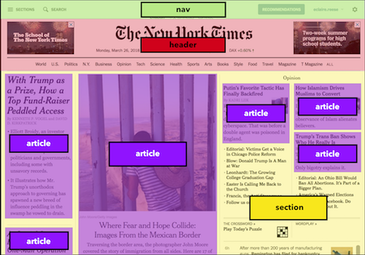

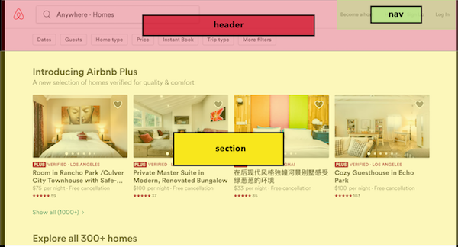

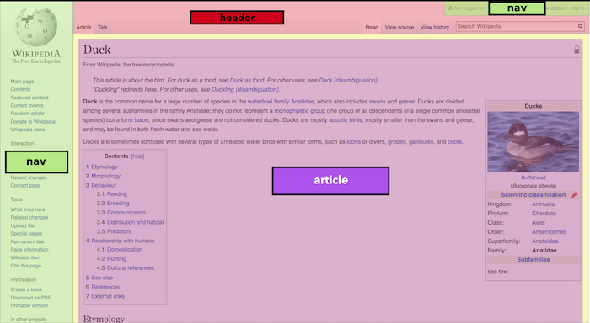

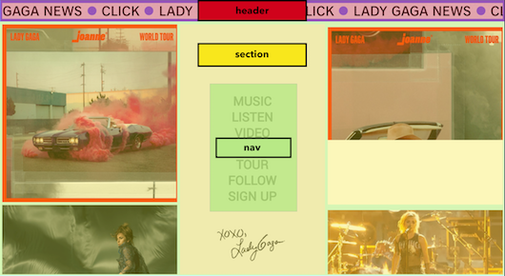

Structural elements in HTML include:

* <header>: the section at the top of a web page that often includes a logo and sometimes a nav
* <nav>: a set of menu items that allow a user to navigate to different pages on a site
* <section>: a general section of related content
* <article>: a piece of content that can be independently shared, like a blog post or newspaper article (even if you don't display the full article text, like you just show a preview, you can still use an article tag to delineate this content)
* <footer>: the section at the bottom of a page that often has additional links and perhaps social sharing icons
* <aside>: content that is complementary but not crucial to the page's main content (this could be an informative side section on a related subject)
* <figure>: a grouped image and caption that create an informative visual of some kind

Let's look at a very generic desktop page structure first:

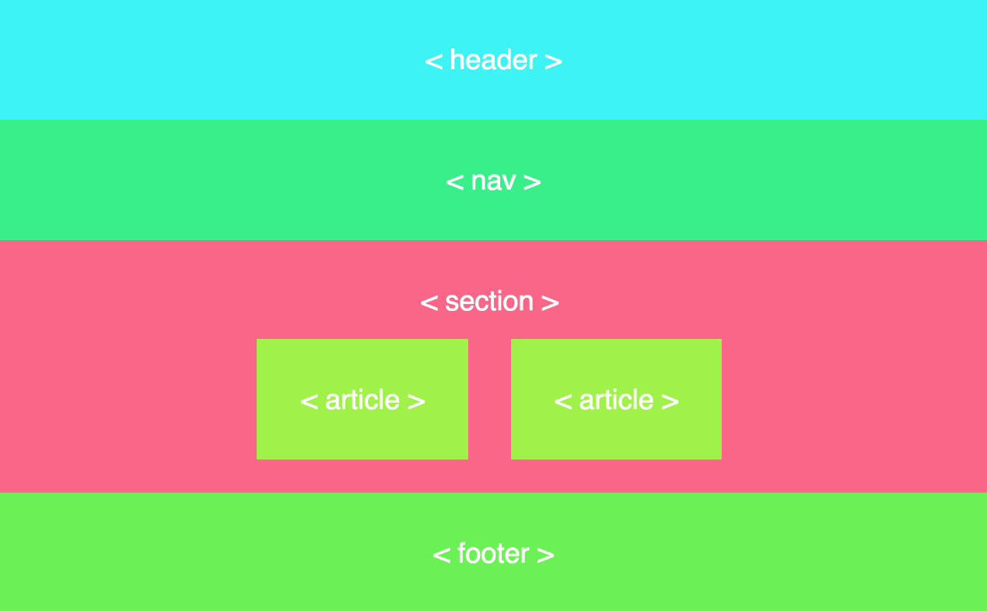

**CSS (Cascading Style Sheets)** is a code language that allows you to control the appearance of your web page. It is used on almost every website.

Web pages are composed of **elements** like headings, paragraphs, images, articles, and more. These elements are created in **HTML**, and their appearances are customized in **CSS**.

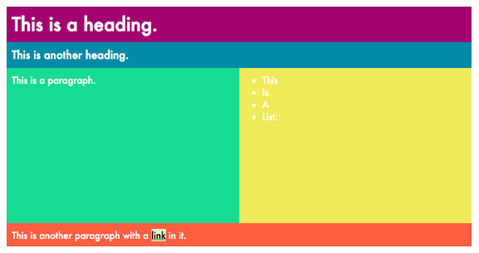

**Elements as boxes**

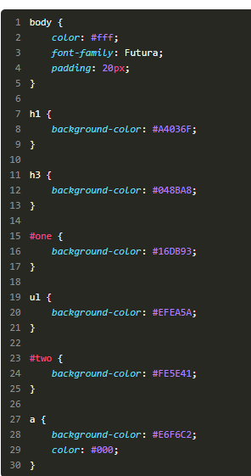Creating layouts requires complete understanding of one key concept: **every HTML element lives in its own box.**This concept is called the **box model.**

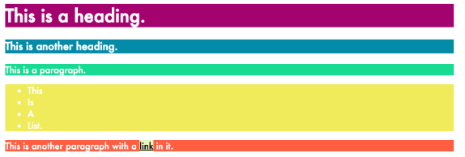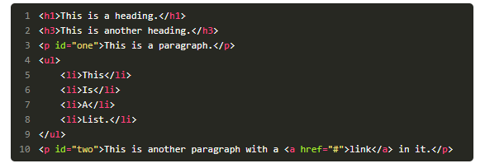

* "Boxes" for block elements take up the whole page, while "boxes" for inline elements will only be as big as the element itself.
* Containing elements or "containers" (ex. a div) have other elements inside them.

## **Add custom borders to elements**

In CSS, you can control a border's:

* **width** (thin, wide, 5px, etc.)
* **style** (solid, dashed, etc.)
* **color** (hex code, RGB value, etc.)

### Border syntax

Before we look at border value examples, there are two general ways to **set borders**:

* **a longhand way** where you list out each value in a different property (ex.  border-width  ,  border-style  , and  border-color  ).
* **a shorthand way** where you combine all values into one property called border

You can set borders in CSS using one simple property called border.

You'll often set borders the shorthand way because it's faster and more concise.

***In it, you will specify three border properties in the following order:***

* width
* 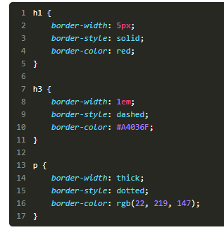style
* 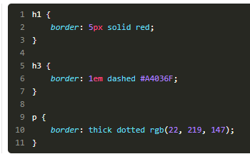color

**shorthand method**

**the longhand way**

### Setting border width

**Border widths** can be set as either **pixel values**, **em/rem values**, or using **a word** that CSS has already pre-defined, like "thin," "medium," or "thick."( 1em means the border will be 16px wide)

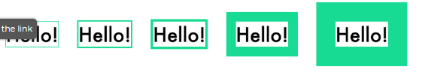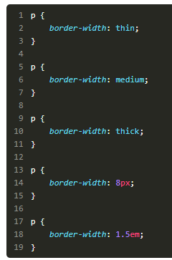

### Setting border style

In reality, you'll most often specify a "solid" **border style**.

Here is the full list of possible options for setting borders in CSS:

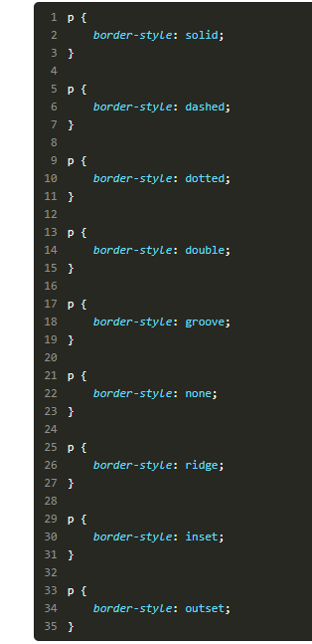Solid, dashed, dotted, double, groove, hidden, none, ridge, inset, outset

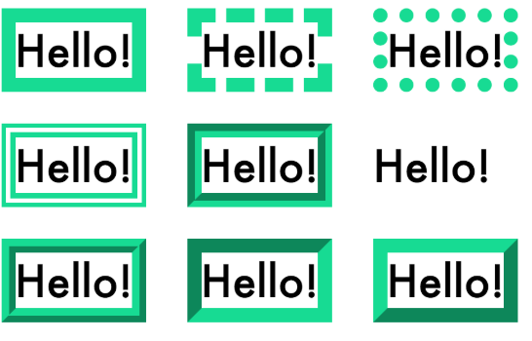

You can even set specific border styles per side by using property names that specify the top, bottom, left, or right border:

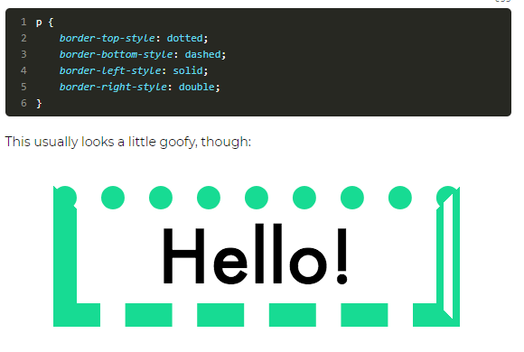

### Setting border color

Set **border colors** the same way you set most colors in CSS, using:

* **hex codes**
* **RGB or RGBA values**
* **color names**
* **hsl values**

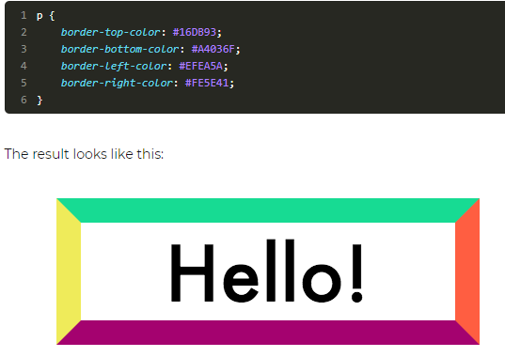

### Setting border radius

Lastly, you can also set rounded borders by using a property called  border-radius  using em/rem values, pixels, or percentages:

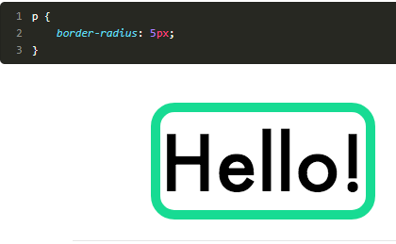

### Recap

* Each HTML element has a border.
* To set the width of a border, use  border-width  and define the size with pixels, em/rem, or special CSS words (thin, medium, thick).
* To set the style, use  border-style  and choose a style from the list of available CSS words.
* To set the color, use  border-color  and use either hex, RGB, or RGBA color codes.
* To set width, style, and color all at once, use the  border  property.
* To set individual borders, use top, right, left, and bottom (ex.  border-top-style ).
* To curve the corners of a border, use  border-radius  .